
VICTORIA JUNIOR COLLEGE

JC2 PRELIMINARY EXAMINATIONS 2026

H2 GEOGRAPHY 9173/02

INSERT 3 hours

READ THESE INSTRUCTIONS

The Insert contains all the Resources referred to in the questions.

This document consists of 9 printed pages
Resource 1 for Question 1

Map of Detroit with Farming Sites

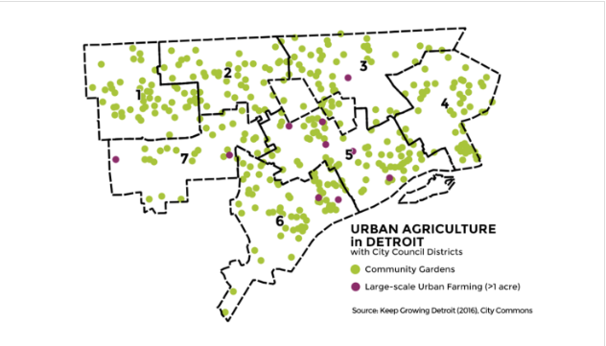
v

Legend:

District 1 – Northwest Detroit – Middle to Upper Middle Income Status
District 2 – North Central/Northwest – Low to Middle Income Status
District 3 – Northeast Detroit – Low Income Status
District 4 – East Side – Low Income Status
District 5 – Midtown and North End – Mixed Income Status
District 6 – Highly Mixed Income Status
District 7 – Low to Middle Income Status
Research sites -

Resource 2 for Question 1

Selected Responses from Interviews

Interviewee | Age | Occupation | Length of Residence | Comments
A | 62 | Retired factory worker | 35 years | “The grocery store closed a few years back, so growing vegetables helps me stretch my pension. I don't have to buy tomatoes, peppers or lettuce during the summer anymore.”
B | 34 | Part-time cleaner | 12 years | "Food has become so expensive. My kids enjoy helping in the garden, and we eat more fresh vegetables now than we used to."
C | 27 | Warehouse worker | 8 years | "I came because my neighbour invited me. At first it was just something to do on Saturdays, but now I've started composting at home because I realised how much food we throw away."
D | 55 | Unemployed | 30 years | "I joined because I wanted to learn gardening skills. Now I waste less food because I know how much effort it takes to grow it."
E | 40 | Home-based nursing assistant | 15 years | "Growing our own vegetables gives me peace of mind. If food prices keep rising, at least we know we can still put healthy meals on the table."
F | 19 | Community college student | Lifelong resident | "I didn't really care much about gardening before. After joining, I realised buying local food probably makes more sense than importing everything from far away."
H | 47 | Delivery driver | 20 years | "Honestly, I'm here because fresh vegetables taste better. I don't really think about climate change that much."
I | 31 | Restaurant kitchen assistant | 10 years | "The workshops taught me how to collect rainwater and compost kitchen scraps. Those are things I never thought about before."

Resource 3 for Question 1

Selected notes from Participant Observation

Observation Note | Photograph | Note
Raised Vegetable Beds | 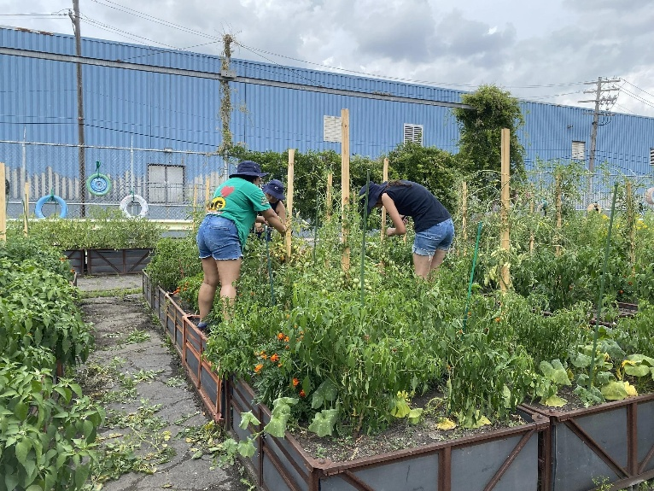 | 18 residents were planting, watering, harvesting.  Experienced gardeners were teaching first-time volunteers.  No vegetables were discarded during harvesting.
Community Composting Area | 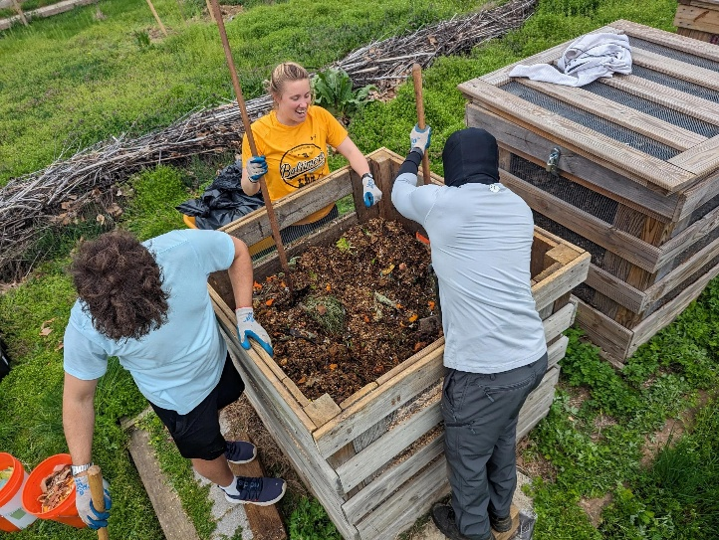 | Four compost bins were located beside the garden entrance and were clearly labelled with acceptable and non-acceptable waste.  Participants deposited fruit peels, vegetable scraps and dried leaves into the compost bins after gardening activities.  No inorganic waste was observed inside the compost bins.
Rainwater Harvesting System | 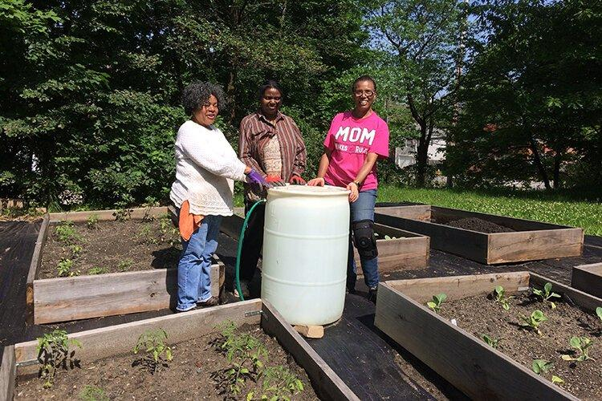 | Two large rainwater storage barrels collected runoff from the roof of a nearby storage shed.  Participants filled watering cans directly from the barrels instead of using tap water.  Watering was prioritised for young vegetable seedlings.
Community Food-Sharing Shelf | 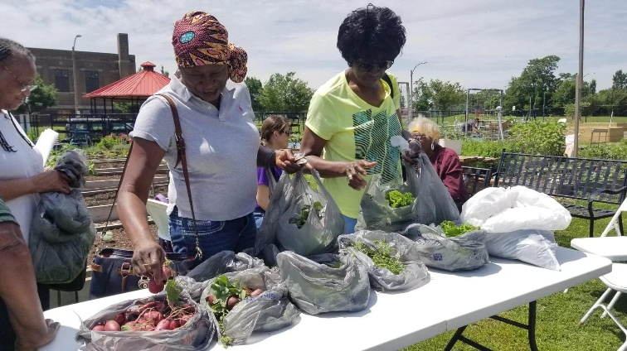 | Freshly harvested tomatoes, lettuce, herbs and zucchini were placed on an open shelf for residents to take free of charge.  One volunteer replenished the shelf with freshly harvested vegetables several times during the morning.  A notice encouraged residents to "Take what you need, leave what you can."

Resource 4 for Question 2

Global Fast Fashion Market

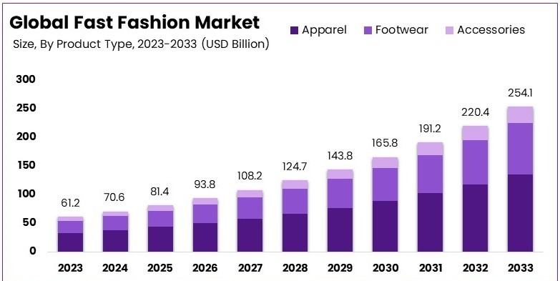

*Fast Fashion: Business model in which clothing companies rapidly design, manufacture and sell inexpensive, trend-driven clothing.

Resource 5 for Question 2

Infographics on ‘Garbage City’, Cairo
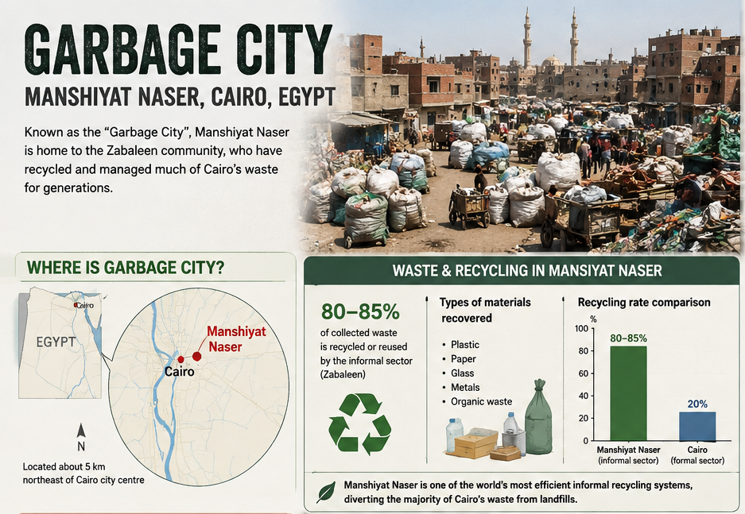

Resource 6 for Question 2
Streets of the ‘Garbage City’

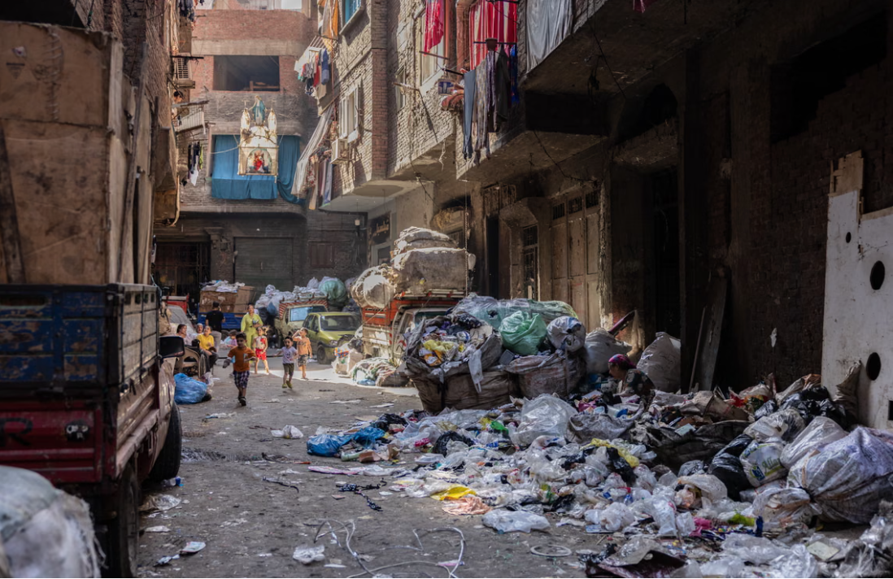
Resource 7 for Question 2

Excerpt on Community actions taken to improve the image of ‘Garbage City’

Many people in Cairo associate Manshiyat Naser, or ‘Garbage City’, with waste and poor living conditions. In 2016, residents worked with French-Tunisian artist eL Seed to create the Perception mural, a giant artwork painted across more than 50 buildings. The mural can only be fully viewed from a specific point on nearby Mokattam Hill. Residents helped paint the mural, hoping to challenge negative stereotypes about their community and highlight the important role the Zabaleen play in recycling most of Cairo's household waste.

The mural has attracted tourists, photographers and media attention from around the world, bringing visitors and new economic opportunities to local businesses. Residents believe the project has strengthened community pride while encouraging outsiders to appreciate their contribution to Cairo's environmental sustainability. Although challenges such as overcrowding and inadequate housing remain, many feel that changing public perceptions has been an important step towards making ‘Garbage City’ a more liveable and inclusive community.

Sources

Resource 1 | https://detroitography.com/2018/11/16/map-community-gardens-and-urban-farms-in-detroit-2017/
Resource 2 | Author’s own.
Resource 3 | Author’s own. Photos from:  https://www.detroitwritingroom.com/2025-journalism-camp-stories/community-gardens-benefit-detroit  https://www.the6thbranch.org/compost-factory  https://www.freshwatercleveland.com/features/SummerSprout071619.aspx  https://www.urbanharveststl.org/foodaccess
Resource 4 | https://market.us/report/fast-fashion-market/
Resource 5 | https://chatgpt.com/s/m_6a72fe0c01788191bc8826490b90bfab
Resource 6 | https://www.theguardian.com/global-development/2025/jul/18/rubbish-recyclers-cairo-garbage-city-manshiyet-nasr-climate-crisis
Resource 7 | Adapted from: https://www.vox.com/2016/3/30/11333224/el-seed-mural-cairo

